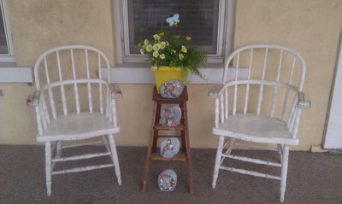

Tabor Public Library Plan
2019-2022

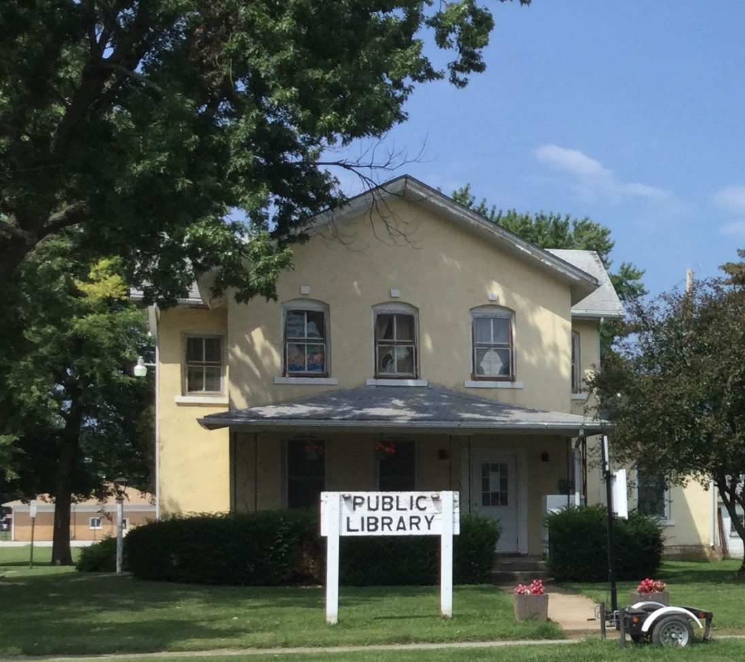
Page 1

The general public was invited to a strategic planning workshop with the goal of establishing consensus on civic betterment initiatives so the city could formulate strategies and target local resources (both human and financial) to accomplish set goals. JEO Consulting Group led the workshop which was also attended by Tabor City Council and city staff. The workshop was a comprehensive and community driven process to collaboratively develop an actionable implementation plan that is sustainable and supported by the community.

Thank you to:
Community members, business owners, and non-resident library users for your input, Mayor James Switzer,City Council Members & City Clerk, City Employees, Library Board of Trustees, Tabor Library Assoc, New Library Building Committee & JEO Consulting Group

Tabor City Council: Mayor James Switzer
Arlene Bartholomew City Clerk Mary King-Bateman
Andrew Wake
Jennifer Williams
Ross Silcock
Randy Wirth

Tabor Library Trustees:
Pres. Angie Alley Janet Roulson Hannah Forney
Vice Pres. Connie Aistrope Lyn Silcock Barb Thomas
Tres. & Sec. Charm Smith Carolyn Wyant Shirley Miller
Mary Donahue Hannah Forney

Library Director Dawn Miller

Tabor, Iowa Vison Implementation Plan (VIP)

Goal: Construct a safe, aesthetically-pleasing, scale-appropriate, energy-efficient, fully accessible, technologically advanced Public Library.
A Public Library is more than a repository of books and computers--it is an essential part of the community. As a tax supported, free public library, its purpose is to serve the diverse informational, educational, cultural and recreational needs and interests of all the residents of Tabor. The Tabor Public Library strives to maintain excellent service by:
- Providing a wide variety of resources that reflect the City's interests and needs.
- Promoting literacy, lifelong learning and intellectual freedom.
- Providing the technological infrastructure necessary to support quality library services.
- Fostering interaction among diverse groups by serving as a focal point for library and community activities.
The City of Tabor should work with the local stakeholders to identify future plans for the future Public Library. Stakeholders should consider the existing site location would likely be cost-prohibitive due technology upgrades and the removal of architectural barriers associated the Americans with Disabilities Act (ADA). The layout of the existing Public Library is not accommodating for classroom programs or events.
A new facility should be equipped with state-of-the-art technological amenities and provide adequate space for current needs and ample room for continued expansion of the Library’s collection and services. Local stakeholders should give strong consideration to the feasibility and cost-effectiveness of incorporating the new Public Library with youth activities to benefit the entire community.
Tabor, Iowa Vison Implementation Plan (VIP) cont. Page 2

Concerns/Needs
- Have architectural concept that needs to be refined
- Would like to start ASAP
- Need funding to construct the new library
- New facility will need better internet
- A new facility could house a tourism office and provide a space for youth activities
- Existing Facility:
- Too small for books collection
- Need classroom for summer reading (90 kids/summer)
- Need a computer lad space
- No Parking
- Not ADA accessible
- Has and will continue to be a teen gathering (Wednesday and Saturday)
- The library has significant Historic data (Genealogy) for the area
Objective 1: Complete design a future Public Library which will accommodate the physical, spatial, educational and technological needs of Tabor.
Action Steps:
1. Continue working with a licensed professional architectural/ engineering consultant to prepare a programming plan for the future Public Library.
2. Refine the program plan as necessary.
3. Consider the spatial needs of the Public Library against the spatial needs/functionality of the youth activities for a multi-use facility.
4. Calculate the land needs requirement for the new Public Library.
5. Finalize the location for the new facility.
6. Prepare and approve the final site design schematic/opinion of cost.

Objective #2: Identify potential resources (both human and financial) for the construction of the new Tabor Public Library.
1. Meet with the Fiscal Agent for the City of Tabor to determine the long-term debt capacity of the community/responsible entity.
2. Identify local, regional, state, federal and in-kind resources for construction of the future Tabor Public Library.
3. Commence fund-raising efforts to solicit public and private contributions for the construction of the new Tabor Public Library.
4. Achieve maximum project impact by leveraging local funds with "outside" resources.
5. Package all financial resources for the construction of the new venue.

Objective #3: Construction of the new Public Library.
1. Conduct an environmental review process, as required by the project’s public funding agencies.
2. Enter into a professional services contract with a professional architectural/engineering firm to develop plans and specifications for the project, as well as for construction observation/management services.
3. Develop plans and specifications for the future Tabor Public Library, pursuant to the responses offered by regulatory agencies and the requirements of public funding sources (International Energy Conservation Code, Americans with Disability, Historic Preservation, etc.).
4. Submit plans and specifications to the public agencies (as appropriate) for their review/approval.
5. Secure necessary permits/approvals from public agencies.
6. Bid phase to include advertising, letting and contract award to lowest responsible/responsive bidder.
7. Construction related activities.
Tabor, Iowa Vison Implementation Plan (VIP) cont. Page3

Responsible Group/Agency
City of Tabor, residents, Public Library Foundation, and Tabor Public Schools.

Potential Resources
Conventional General Obligation Bonds, Tabor Capital Improvement Fund, Tabor General Fund, Sales Tax, USDA Rural Development Community Facility Loan Program, private donations, local volunteers, Iowa West Foundation, Community Development Assistance Act - Tax Credit Program, and local fund raising events.

Measurable Outputs
Construction of a new facility equipped with state-of-the-art technological amenities, parking and adequate space for current needs and ample room for continued expansion of the Library’s collection and services.

Tabor Public Library Mission Statement
The Tabor Public Library seeks to be an integral part of its community by providing the residents of the community and surrounding area with a wide variety of popular and educational materials, programs, resources, and services that facilitate their day to day lives and extend their personal and intellectual development. The library supports lifelong learning, early literacy development cultural and recreational activities, and the technology and information needs of the people it serves. The Tabor Public Library seeks to build knowledge, understanding, appreciation, and wisdom in a welcoming environment.

Tabor Public Library Vision
Three elements of a library combine in equal parts to provide excellent customer service:
Collection
Staff
Facilities
The Tabor Public Library will continue to provide excellent service to our customers because we:
- Acknowledge that our customers drive everything we do as we enhance traditional services and implement new and innovative services.
- Draw our community into a dynamic environment that encourages a love of reading, lifelong learning, wellness, and healthy living.
- Provide friendly, helpful, and knowledgeable staff.
- Use the power of technology to optimize the community’s access to library services as well as local, state, and global information.
- Incorporate library services into the fabric of the community through alliances and partnerships with other libraries, organizations, resulting in strong community pride.
- Nurture appreciation of literature, the ever-changing world of information, and healthy living.

Tabor Public Library Goals & Objectives 2019-2022 Page 4

Goal: The community will become aware of all that the library has to offer by an active marketing program shared with patrons and the media in the next 3 years.
Objective: Branding of the library to take place over the next 3 years as the community transitions to a new facility.
Action: Create an overall marketing plan with a "tagline" over the next 12-18 months to culminate with the opening of our new facility.
Action: Create and use a logo and template with a uniform look (colors and fonts) to match our new signage and use it for flyers and promotional materials.
Action: Create a library brochure that can be used in city welcome packets (Tabor and Thurman), at off-site events, and when giving tours of our library
Action: Seek funding through grants for the marketing that will take place for the library.
Objective: Increase sharing of library news in the paper media throughout the year.
Action: The library staff will update the library website, bi-monthly
Action: The library staff will share monthly programs and activities on KMA Community Calendar
Action: See if the newspaper would consider adding a monthly column featuring news at the library. Prepare twelve-month plan for columns with board of trustees involvement.
Action: Explore costs of advertising in area newspapers to announce major programs twice a year to reach residents in a broader area, The Weekly Times and Town and Country Shopper.

Goal: Increase awareness and use of the library's electronic services to patrons of all ages starting in the summer of 2019 and work for a 5% increase annually.
Objective: Promote the use of the electronic services available throughout the year.
Action: Update website to include logo with link for available e-services, add a description of each service and add a link to a "how to" page for services by July 2019.
Action: Prepare a schedule for promoting electronic services. Focus on one service for a one-month period. Plan a teaching session, feature that service in the newspaper, on social media and at the library for that month. Use printed promotional materials to hand out with checked out materials.
Objective: Increase use of electronic services that are available through the library by 5% annually
Action: Beginning spring 2019 library staff will use online resources/webinars for technology training and will continue with at least one monthly so they can be up to date with emerging technology.
Action: Develop and/or make available printed and online tools and guide that will help patrons with electronic services. Have them at the checkout counter and near the library computer stations. Also have them at of- site events happening during that month.
Action: Promote services that are available such as specific books, music, ebooks, etc. to residents and patrons using advertising on Facebook and social media.

Tabor Public Library Goals & Objectives 2019-2022 cont. Page 5

Goal: In 2019, seek additional and adequate funding to build and equip the new facility.
Objective: Trustees and capital campaign committee members will seek and accept funds from the community and foundation grants to serve all age groups of the community.
Action: The Library Association will assist in the process through fundraisers and community awareness activities.
Action: The library staff will survey the community for programming and material needs and wants.

Goal: In 2020, implement architectural designs and work with the engineering firm to accomplish goals for the new facility.
Objective: Trustees will coordinate with the JEO, City Council and City staff to begin the building process.
Action: The Library Association will disburse funds for the project.

Goal: Implement nutrition, wellness, active living and aging programs that will be 1st steps to marketing and promoting our Healthy Living Hub in our new facility.
Objective: Impact patron’s overall health and well-being with programming that will further their knowledge and give them hands-on learning activities.
Action: Identify four topics and ask community experts from local businesses or colleges/high schools to present workshops in our learning space.
Action: Use the marketing campaign to reach target groups for the four classes using the library branding through the library's presence on social media, in the press and on the library website.

Goal: Collect input and feedback on the programs, events, and services the library offers.
Objective: To offer programs, events and services to our patrons that will have the most community impact
Action: Beginning with the Summer 2019 programs we will hand have surveys at each program or event that will be used to collect patron feedback and input about the program, presenter, take away and more.
Action: Beginning spring 2019 we will have comment and suggestion cards at the circulation desk at the library for materials, services and customer service.
Action: All surveys, comments and suggestions will be shared monthly at board meetings and decisions for future programs events and services will be taken into consideration from the data collected.

Goal: Organize and create STEM kits to make libraries STEM materials available check out.
Objective: Share the STEM materials the library has acquired with others to create learning environments for families, homeschoolers, organizations, and more.
Action: Beginning in Fall 2019 through all the libraries STEM materials and organize them into categories then create smaller STEM Kits which would then be added to our automation system and be able to be checked out by patrons, organizations and other libraries as needed.

